REST - Get country based on country code

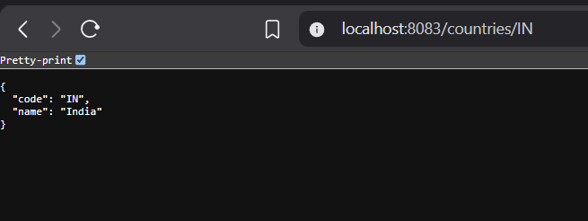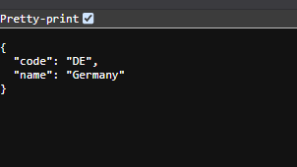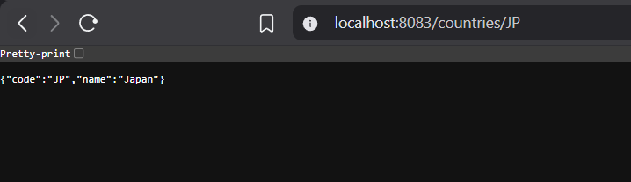

Console output
/\\ / ___'_ __ _ _(_)_ __ __ _ \ \ \ \
( ( )\___ | '_ | '_| | '_ \/ _` | \ \ \ \
\\/ ___)| |_)| | | | | || (_| | ) ) ) )
' |____| .__|_| |_|_| |_\__, | / / / /
=========|_|==============|___/=/_/_/_/
:: Spring Boot :: (v3.5.16)
2026-07-05T15:06:49.476+05:30 INFO 2180 --- [spring-learn] [ restartedMain] c.c.spring_learn.SpringLearnApplication : Starting SpringLearnApplication using Java 21.0.7 with PID 2180 (C:\Users\mayank rawat\Downloads\spring-learn\spring-learn\target\classes started by mayank rawat in C:\Users\mayank rawat\Downloads\spring-learn\spring-learn)
2026-07-05T15:06:49.480+05:30 DEBUG 2180 --- [spring-learn] [ restartedMain] c.c.spring_learn.SpringLearnApplication : Running with Spring Boot v3.5.16, Spring v6.2.19
2026-07-05T15:06:49.481+05:30 INFO 2180 --- [spring-learn] [ restartedMain] c.c.spring_learn.SpringLearnApplication : No active profile set, falling back to 1 default profile: "default"
2026-07-05T15:06:49.617+05:30 INFO 2180 --- [spring-learn] [ restartedMain] .e.DevToolsPropertyDefaultsPostProcessor : Devtools property defaults active! Set 'spring.devtools.add-properties' to 'false' to disable
2026-07-05T15:06:49.617+05:30 INFO 2180 --- [spring-learn] [ restartedMain] .e.DevToolsPropertyDefaultsPostProcessor : For additional web related logging consider setting the 'logging.level.web' property to 'DEBUG'
2026-07-05T15:06:55.266+05:30 INFO 2180 --- [spring-learn] [ restartedMain] o.s.b.w.embedded.tomcat.TomcatWebServer : Tomcat initialized with port 8083 (http)
2026-07-05T15:06:55.312+05:30 INFO 2180 --- [spring-learn] [ restartedMain] o.apache.catalina.core.StandardService : Starting service [Tomcat]
2026-07-05T15:06:55.313+05:30 INFO 2180 --- [spring-learn] [ restartedMain] o.apache.catalina.core.StandardEngine : Starting Servlet engine: [Apache Tomcat/10.1.55]
2026-07-05T15:06:55.538+05:30 INFO 2180 --- [spring-learn] [ restartedMain] o.a.c.c.C.[Tomcat].[localhost].[/] : Initializing Spring embedded WebApplicationContext
2026-07-05T15:06:55.541+05:30 INFO 2180 --- [spring-learn] [ restartedMain] w.s.c.ServletWebServerApplicationContext : Root WebApplicationContext: initialization completed in 5873 ms
2026-07-05T15:06:58.069+05:30 INFO 2180 --- [spring-learn] [ restartedMain] o.s.b.d.a.OptionalLiveReloadServer : LiveReload server is running on port 35729
2026-07-05T15:06:58.642+05:30 INFO 2180 --- [spring-learn] [ restartedMain] o.s.b.w.embedded.tomcat.TomcatWebServer : Tomcat started on port 8083 (http) with context path '/'
2026-07-05T15:06:58.661+05:30 INFO 2180 --- [spring-learn] [ restartedMain] c.c.spring_learn.SpringLearnApplication : Started SpringLearnApplication in 10.661 seconds (process running for 11.371)
2026-07-05T15:07:46.182+05:30 INFO 2180 --- [spring-learn] [nio-8083-exec-1] o.a.c.c.C.[Tomcat].[localhost].[/] : Initializing Spring DispatcherServlet 'dispatcherServlet'
2026-07-05T15:07:46.183+05:30 INFO 2180 --- [spring-learn] [nio-8083-exec-1] o.s.web.servlet.DispatcherServlet : Initializing Servlet 'dispatcherServlet'
2026-07-05T15:07:46.184+05:30 INFO 2180 --- [spring-learn] [nio-8083-exec-1] o.s.web.servlet.DispatcherServlet : Completed initialization in 1 ms
2026-07-05T15:07:46.517+05:30 DEBUG 2180 --- [spring-learn] [nio-8083-exec-1] com.cognizant.spring_learn.Country : Inside Country Constructor.
2026-07-05T15:07:46.521+05:30 DEBUG 2180 --- [spring-learn] [nio-8083-exec-1] com.cognizant.spring_learn.Country : Inside setCode()
2026-07-05T15:07:46.522+05:30 DEBUG 2180 --- [spring-learn] [nio-8083-exec-1] com.cognizant.spring_learn.Country : Inside setName()
2026-07-05T15:07:46.523+05:30 DEBUG 2180 --- [spring-learn] [nio-8083-exec-1] com.cognizant.spring_learn.Country : Inside Country Constructor.
2026-07-05T15:07:46.523+05:30 DEBUG 2180 --- [spring-learn] [nio-8083-exec-1] com.cognizant.spring_learn.Country : Inside setCode()
2026-07-05T15:07:46.523+05:30 DEBUG 2180 --- [spring-learn] [nio-8083-exec-1] com.cognizant.spring_learn.Country : Inside setName()
2026-07-05T15:07:46.523+05:30 DEBUG 2180 --- [spring-learn] [nio-8083-exec-1] com.cognizant.spring_learn.Country : Inside Country Constructor.
2026-07-05T15:07:46.523+05:30 DEBUG 2180 --- [spring-learn] [nio-8083-exec-1] com.cognizant.spring_learn.Country : Inside setCode()
2026-07-05T15:07:46.523+05:30 DEBUG 2180 --- [spring-learn] [nio-8083-exec-1] com.cognizant.spring_learn.Country : Inside setName()
2026-07-05T15:07:46.523+05:30 DEBUG 2180 --- [spring-learn] [nio-8083-exec-1] com.cognizant.spring_learn.Country : Inside Country Constructor.
2026-07-05T15:07:46.524+05:30 DEBUG 2180 --- [spring-learn] [nio-8083-exec-1] com.cognizant.spring_learn.Country : Inside setCode()
2026-07-05T15:07:46.524+05:30 DEBUG 2180 --- [spring-learn] [nio-8083-exec-1] com.cognizant.spring_learn.Country : Inside setName()
2026-07-05T15:07:46.530+05:30 DEBUG 2180 --- [spring-learn] [nio-8083-exec-1] com.cognizant.spring_learn.Country : Inside getCode()
2026-07-05T15:07:46.606+05:30 DEBUG 2180 --- [spring-learn] [nio-8083-exec-1] com.cognizant.spring_learn.Country : Inside getCode()
2026-07-05T15:07:46.606+05:30 DEBUG 2180 --- [spring-learn] [nio-8083-exec-1] com.cognizant.spring_learn.Country : Inside getName()
2026-07-05T15:08:24.660+05:30 DEBUG 2180 --- [spring-learn] [nio-8083-exec-5] com.cognizant.spring_learn.Country : Inside Country Constructor.
2026-07-05T15:08:24.661+05:30 DEBUG 2180 --- [spring-learn] [nio-8083-exec-5] com.cognizant.spring_learn.Country : Inside setCode()
2026-07-05T15:08:24.661+05:30 DEBUG 2180 --- [spring-learn] [nio-8083-exec-5] com.cognizant.spring_learn.Country : Inside setName()
2026-07-05T15:08:24.662+05:30 DEBUG 2180 --- [spring-learn] [nio-8083-exec-5] com.cognizant.spring_learn.Country : Inside Country Constructor.
2026-07-05T15:08:24.662+05:30 DEBUG 2180 --- [spring-learn] [nio-8083-exec-5] com.cognizant.spring_learn.Country : Inside setCode()
2026-07-05T15:08:24.662+05:30 DEBUG 2180 --- [spring-learn] [nio-8083-exec-5] com.cognizant.spring_learn.Country : Inside setName()
2026-07-05T15:08:24.662+05:30 DEBUG 2180 --- [spring-learn] [nio-8083-exec-5] com.cognizant.spring_learn.Country : Inside Country Constructor.
2026-07-05T15:08:24.662+05:30 DEBUG 2180 --- [spring-learn] [nio-8083-exec-5] com.cognizant.spring_learn.Country : Inside setCode()
2026-07-05T15:08:24.662+05:30 DEBUG 2180 --- [spring-learn] [nio-8083-exec-5] com.cognizant.spring_learn.Country : Inside setName()
2026-07-05T15:08:24.663+05:30 DEBUG 2180 --- [spring-learn] [nio-8083-exec-5] com.cognizant.spring_learn.Country : Inside Country Constructor.
2026-07-05T15:08:24.663+05:30 DEBUG 2180 --- [spring-learn] [nio-8083-exec-5] com.cognizant.spring_learn.Country : Inside setCode()
2026-07-05T15:08:24.663+05:30 DEBUG 2180 --- [spring-learn] [nio-8083-exec-5] com.cognizant.spring_learn.Country : Inside setName()
2026-07-05T15:08:24.666+05:30 DEBUG 2180 --- [spring-learn] [nio-8083-exec-5] com.cognizant.spring_learn.Country : Inside getCode()
2026-07-05T15:08:24.669+05:30 DEBUG 2180 --- [spring-learn] [nio-8083-exec-5] com.cognizant.spring_learn.Country : Inside getCode()
2026-07-05T15:08:24.669+05:30 DEBUG 2180 --- [spring-learn] [nio-8083-exec-5] com.cognizant.spring_learn.Country : Inside getName()
2026-07-05T15:08:39.446+05:30 DEBUG 2180 --- [spring-learn] [nio-8083-exec-2] com.cognizant.spring_learn.Country : Inside Country Constructor.
2026-07-05T15:08:39.447+05:30 DEBUG 2180 --- [spring-learn] [nio-8083-exec-2] com.cognizant.spring_learn.Country : Inside setCode()
2026-07-05T15:08:39.447+05:30 DEBUG 2180 --- [spring-learn] [nio-8083-exec-2] com.cognizant.spring_learn.Country : Inside setName()
2026-07-05T15:08:39.447+05:30 DEBUG 2180 --- [spring-learn] [nio-8083-exec-2] com.cognizant.spring_learn.Country : Inside Country Constructor.
2026-07-05T15:08:39.447+05:30 DEBUG 2180 --- [spring-learn] [nio-8083-exec-2] com.cognizant.spring_learn.Country : Inside setCode()
2026-07-05T15:08:39.447+05:30 DEBUG 2180 --- [spring-learn] [nio-8083-exec-2] com.cognizant.spring_learn.Country : Inside setName()
2026-07-05T15:08:39.447+05:30 DEBUG 2180 --- [spring-learn] [nio-8083-exec-2] com.cognizant.spring_learn.Country : Inside Country Constructor.
2026-07-05T15:08:39.447+05:30 DEBUG 2180 --- [spring-learn] [nio-8083-exec-2] com.cognizant.spring_learn.Country : Inside setCode()
2026-07-05T15:08:39.447+05:30 DEBUG 2180 --- [spring-learn] [nio-8083-exec-2] com.cognizant.spring_learn.Country : Inside setName()
2026-07-05T15:08:39.447+05:30 DEBUG 2180 --- [spring-learn] [nio-8083-exec-2] com.cognizant.spring_learn.Country : Inside Country Constructor.
2026-07-05T15:08:39.447+05:30 DEBUG 2180 --- [spring-learn] [nio-8083-exec-2] com.cognizant.spring_learn.Country : Inside setCode()
2026-07-05T15:08:39.448+05:30 DEBUG 2180 --- [spring-learn] [nio-8083-exec-2] com.cognizant.spring_learn.Country : Inside setName()
2026-07-05T15:08:39.450+05:30 DEBUG 2180 --- [spring-learn] [nio-8083-exec-2] com.cognizant.spring_learn.Country : Inside getCode()
2026-07-05T15:08:39.451+05:30 DEBUG 2180 --- [spring-learn] [nio-8083-exec-2] com.cognizant.spring_learn.Country : Inside getCode()
2026-07-05T15:08:39.451+05:30 DEBUG 2180 --- [spring-learn] [nio-8083-exec-2] com.cognizant.spring_learn.Country : Inside getCode()
2026-07-05T15:08:39.453+05:30 DEBUG 2180 --- [spring-learn] [nio-8083-exec-2] com.cognizant.spring_learn.Country : Inside getCode()
2026-07-05T15:08:39.453+05:30 DEBUG 2180 --- [spring-learn] [nio-8083-exec-2] com.cognizant.spring_learn.Country : Inside getName()
2026-07-05T15:09:01.840+05:30 DEBUG 2180 --- [spring-learn] [nio-8083-exec-4] com.cognizant.spring_learn.Country : Inside Country Constructor.
2026-07-05T15:09:01.841+05:30 DEBUG 2180 --- [spring-learn] [nio-8083-exec-4] com.cognizant.spring_learn.Country : Inside setCode()
2026-07-05T15:09:01.841+05:30 DEBUG 2180 --- [spring-learn] [nio-8083-exec-4] com.cognizant.spring_learn.Country : Inside setName()
2026-07-05T15:09:01.841+05:30 DEBUG 2180 --- [spring-learn] [nio-8083-exec-4] com.cognizant.spring_learn.Country : Inside Country Constructor.
2026-07-05T15:09:01.842+05:30 DEBUG 2180 --- [spring-learn] [nio-8083-exec-4] com.cognizant.spring_learn.Country : Inside setCode()
2026-07-05T15:09:01.842+05:30 DEBUG 2180 --- [spring-learn] [nio-8083-exec-4] com.cognizant.spring_learn.Country : Inside setName()
2026-07-05T15:09:01.842+05:30 DEBUG 2180 --- [spring-learn] [nio-8083-exec-4] com.cognizant.spring_learn.Country : Inside Country Constructor.
2026-07-05T15:09:01.842+05:30 DEBUG 2180 --- [spring-learn] [nio-8083-exec-4] com.cognizant.spring_learn.Country : Inside setCode()
2026-07-05T15:09:01.842+05:30 DEBUG 2180 --- [spring-learn] [nio-8083-exec-4] com.cognizant.spring_learn.Country : Inside setName()
2026-07-05T15:09:01.843+05:30 DEBUG 2180 --- [spring-learn] [nio-8083-exec-4] com.cognizant.spring_learn.Country : Inside Country Constructor.
2026-07-05T15:09:01.844+05:30 DEBUG 2180 --- [spring-learn] [nio-8083-exec-4] com.cognizant.spring_learn.Country : Inside setCode()
2026-07-05T15:09:01.844+05:30 DEBUG 2180 --- [spring-learn] [nio-8083-exec-4] com.cognizant.spring_learn.Country : Inside setName()
2026-07-05T15:09:01.847+05:30 DEBUG 2180 --- [spring-learn] [nio-8083-exec-4] com.cognizant.spring_learn.Country : Inside getCode()
2026-07-05T15:09:01.847+05:30 DEBUG 2180 --- [spring-learn] [nio-8083-exec-4] com.cognizant.spring_learn.Country : Inside getCode()
2026-07-05T15:09:01.847+05:30 DEBUG 2180 --- [spring-learn] [nio-8083-exec-4] com.cognizant.spring_learn.Country : Inside getCode()
2026-07-05T15:09:01.847+05:30 DEBUG 2180 --- [spring-learn] [nio-8083-exec-4] com.cognizant.spring_learn.Country : Inside getCode()
2026-07-05T15:09:01.850+05:30 DEBUG 2180 --- [spring-learn] [nio-8083-exec-4] com.cognizant.spring_learn.Country : Inside getCode()
2026-07-05T15:09:01.850+05:30 DEBUG 2180 --- [spring-learn] [nio-8083-exec-4] com.cognizant.spring_learn.Country : Inside getName()

SpringLearnApplication.java
package com.cognizant.spring_learn;
import org.slf4j.Logger;
import org.slf4j.LoggerFactory;
import org.springframework.boot.SpringApplication;
import org.springframework.boot.autoconfigure.SpringBootApplication;
import org.springframework.context.ApplicationContext;
import org.springframework.context.support.ClassPathXmlApplicationContext;
@SpringBootApplication
public class SpringLearnApplication {
private static final Logger LOGGER =
LoggerFactory.getLogger(SpringLearnApplication.class);
public static void main(String[] args) {
SpringApplication.run(SpringLearnApplication.class, args);
//displayCountry();
}
public static void displayCountry() {
ApplicationContext context =
new ClassPathXmlApplicationContext("country.xml");
Country country =
context.getBean("country", Country.class);
LOGGER.debug("Country : {}", country.toString());
((ClassPathXmlApplicationContext) context).close();
}
}

Application.properties
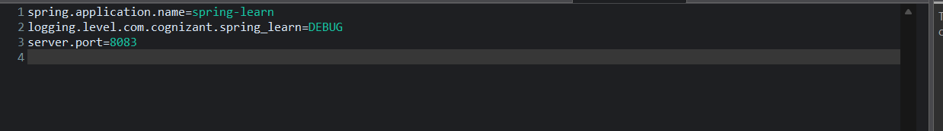

HelloController.java
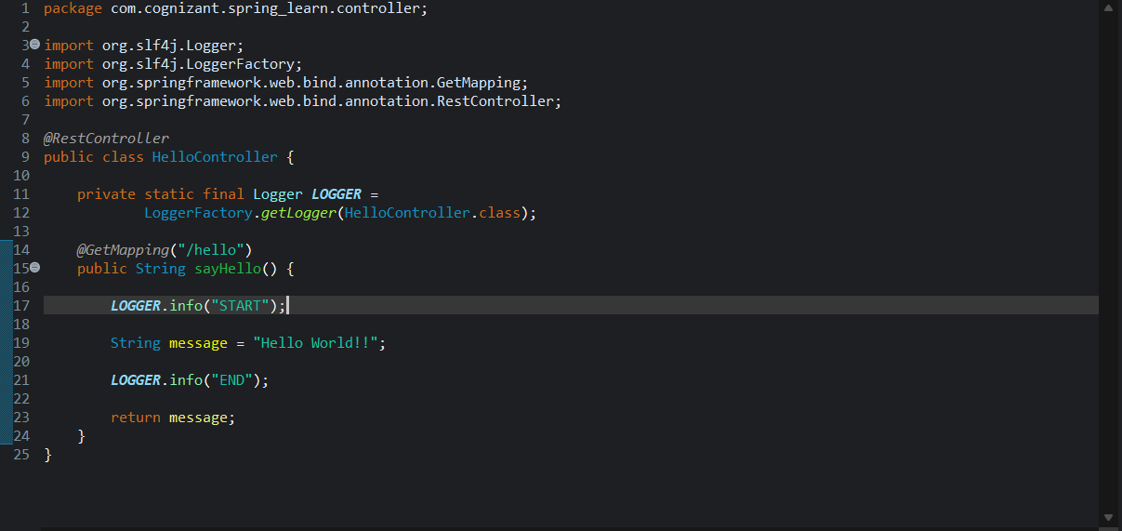

CountryController.java
package com.cognizant.spring_learn.controller;
import org.springframework.beans.factory.annotation.Autowired;
import org.springframework.web.bind.annotation.GetMapping;
import org.springframework.web.bind.annotation.PathVariable;
import org.springframework.web.bind.annotation.RestController;
import com.cognizant.spring_learn.Country;
import com.cognizant.spring_learn.service.CountryService;
@RestController
public class CountryController {
@Autowired
private CountryService countryService;
@GetMapping("/countries/{code}")
public Country getCountry(@PathVariable String code) {
return countryService.getCountry(code);
}
}

Country.xml
<?xml version="1.0" encoding="UTF-8"?>
<beans xmlns="http://www.springframework.org/schema/beans"
xmlns:xsi="http://www.w3.org/2001/XMLSchema-instance"
xsi:schemaLocation="
http://www.springframework.org/schema/beans
https://www.springframework.org/schema/beans/spring-beans.xsd">
<bean id="countryList" class="java.util.ArrayList">
<constructor-arg>
<list>
<bean class="com.cognizant.spring_learn.Country">
<property name="code" value="IN"/>
<property name="name" value="India"/>
</bean>
<bean class="com.cognizant.spring_learn.Country">
<property name="code" value="US"/>
<property name="name" value="United States"/>
</bean>
<bean class="com.cognizant.spring_learn.Country">
<property name="code" value="DE"/>
<property name="name" value="Germany"/>
</bean>
<bean class="com.cognizant.spring_learn.Country">
<property name="code" value="JP"/>
<property name="name" value="Japan"/>
</bean>
</list>
</constructor-arg>
</bean>
</beans>

